1.

For year1

Average Balance = 135.9, Volatility 3.21

For year2

Average Balance = 141.4, Volatility = 4.38

2.

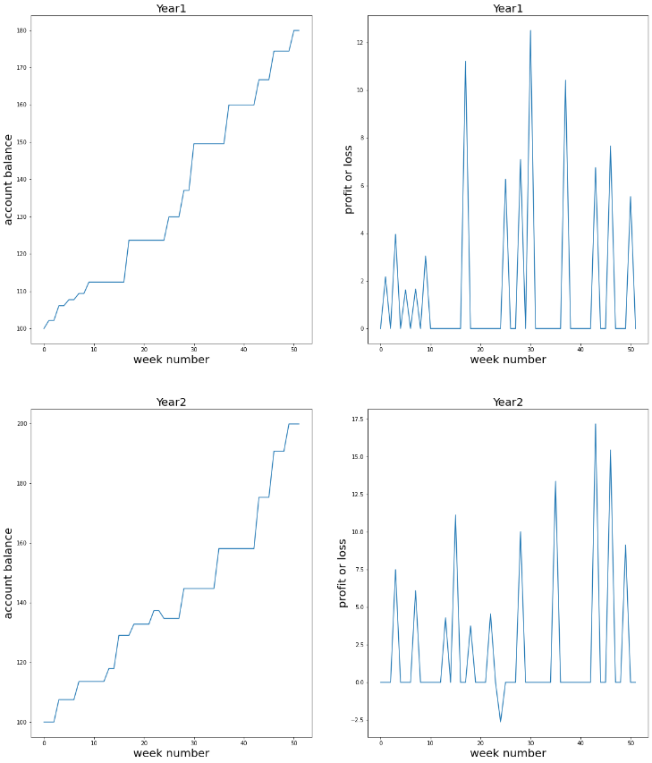

3.

For year1 weekly balance:

Min = 100, max = 179.9

For year2 weekly balance

Min = 100, max = 199.8

4.

Year1 Final = 179.9, Year2 Final = 199.8

5.

For year1

Max increase = 52, Max decrease = 0

For year2

Max increase = 27

Max decrease = 1